

**BCA203-1: Principles Of Software Development**

**Software Requirement Specification (SRS) Document**

by Shaun Roy(2441555)

BCA261-2: Full Stack Development

Submitted to:

Prof/Dr. Rohini V.

Assignment report submitted in partial fulfilment of the requirements for the Principles of Software Development CIA 3 submission of CHRIST (Deemed to be University)

## Table of Contents

1. Introduction

- 1.1 Introduction to the Project

- 1.2 Scope of the Application

- 1.3 Tech Stack

2. Description

- 2.1 Why is this Application Required?

- 2.2 Module Description

- 2.3 Sub-Modules Description

3. Requirements

- 3.1 Software Requirements

- 3.2 Hardware Requirements

4. Primary Use Cases

- 4.1 Table Description

- 4.2 Data Flow Diagram

5. Application Links, Definitions & Acronyms, Conclusion

## 1. Introduction

### 1.1 Introduction to the Project

LifeFlowHub is a straightforward yet powerful web application that represents a modern approach to personal development and lifestyle management. Built using fundamental web technologies, the platform helps users track their habits, set and achieve goals, monitor their health, and manage their educational tasks. The application emphasizes simplicity and accessibility, requiring only a web browser to function effectively.

Our implementation focuses on creating a responsive and intuitive user interface that operates entirely within the browser, ensuring that users can access their personal development tools without the need for complex backend systems or databases.

### 1.2 Scope of the Application

The application encompasses several key features designed to enhance personal development and daily life management:

Primary Features:

- Daily and weekly habit tracking with visual progress indicators

- Goal-setting system with milestone tracking

- Basic health and wellness monitoring tools

- Educational task management and study planning

- Cross-module insights for understanding personal patterns

User Interface Elements:

- Clean, intuitive dashboard design

- Simple navigation between different modules

- Progress visualization through basic charts

- Easy-to-use forms for data entry

Technical Implementation:

- Browser-based data storage using localStorage

- Responsive design for different screen sizes

- Basic offline functionality

- Simple data backup through export/import

### 1.3 Tech Stack

Our technology stack focuses on fundamental web technologies and minimal development tools:

Development Environment:

1. Visual Studio Code

- Live Server extension for development

- HTML CSS Support extension

- JavaScript (ES6) code snippets

Core Technologies:

1. HTML5

- Semantic markup

- Form elements

- Local storage

2. CSS3

- Flexbox layout

- Grid system

- Media queries

3. JavaScript

- DOM manipulation

- Event handling

- Local storage management

## 2. Description

### 2.1 Why is this Application Required?

LifeFlowHub addresses several important needs in personal development:

User Needs:

1. Simple tool for tracking daily habits and routines

2. Straightforward goal-setting and monitoring system

3. Basic health and wellness tracking capabilities

4. Organized approach to educational planning

Benefits:

1. Improved daily routine management

2. Better goal achievement through structured tracking

3. Enhanced awareness of health patterns

4. More efficient study planning and task management

### 2.2 Module Description

The application consists of four core modules:

Habit Tracking Module:

1. Simple habit creation interface

2. Basic progress tracking

3. Daily reminder system

4. Visual streak counter

Goal Setting Module:

1. Goal creation form

2. Milestone tracking

3. Progress indicators

4. Achievement markers

Health and Wellness Module:

1. Basic activity logging

2. Simple nutrition tracking

3. Sleep record keeping

4. Mood tracking

Educational Planning Module:

1. Task list management

2. Basic study scheduler

3. Progress tracking

4. Resource links organization

### 2.3 Sub-Modules Description

Interface Sub-modules:

1. Form Handlers

- Data validation

- Input processing

- Error messaging

2. Display Components

- Progress bars

- Simple charts

- Status indicators

- Alert messages

## 3. Requirements

### 3.1 Software Requirements

Essential Software:

1. Visual Studio Code

- Version: Latest stable release

- Required extensions: Live Server

Browser Requirements:

1. Modern web browser

- Chrome (latest version)

- Firefox (latest version)

- Edge (latest version)

### 3.2 Hardware Requirements

Minimum System Requirements:

1. Processor: Basic 1.6 GHz processor

2. RAM: 4 GB

3. Storage: 500 MB free space

4. Display: 1280x720 resolution

5. Internet connection for initial loading

## 4. Primary Use Cases

### 4.1 Table Description

|  |  |  |  |
| --- | --- | --- | --- |
| TITLE | ACTOR | MAIN FLOW | ALTERNATIVE FLOW |
| Create habit | User | 1. Click the "New Habit" button  2. Fill habit details  3. Set frequency  4. Click Save | - Edit existing habit  - Delete habit  - View progress |
| Track goal | User | 1. Select "Goals" tab  2. Enter goal details  3. Add milestones  4. Save goal | - Update progress  - Mark complete  - Delete goal |
| Log health | User | 1. Open health tracker  2. Enter daily metrics  3. Add notes  4. Save entry | - View history  - Edit entry  - Delete entry |
| Plan tasks | User | 1. Go to planner  2. Add study task  3. Set a deadline  4. Save plan | - Mark complete  - Edit task  - Remove task |

### 4.2 Data Flow Diagram

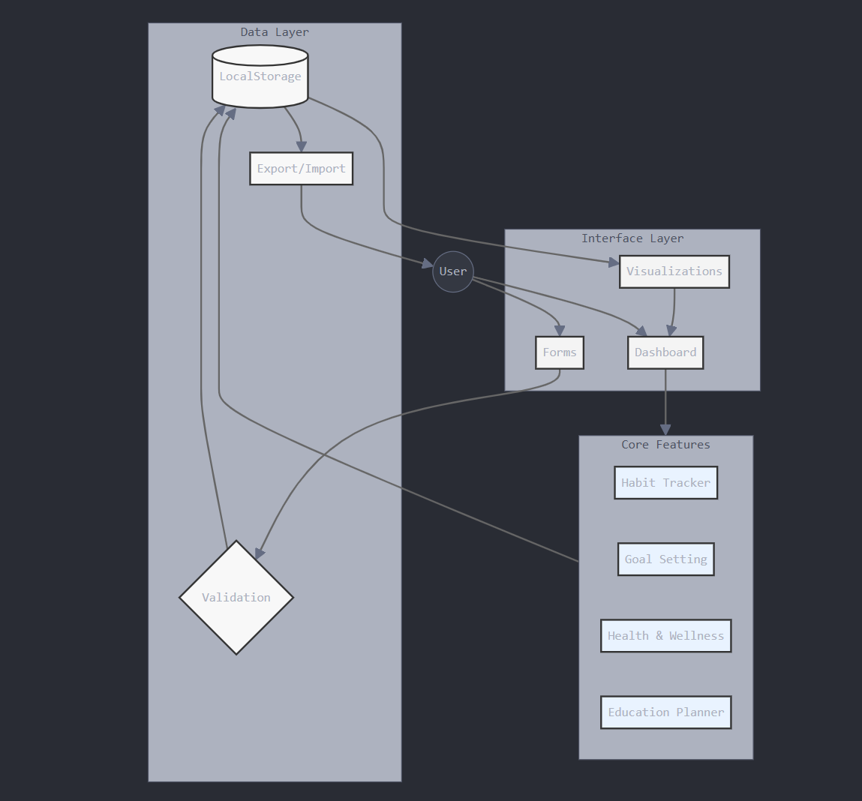

## 5. Conclusion

LifeFlowHub demonstrates how fundamental web technologies can be used to create a practical and effective personal development tool. By focusing on essential features and a straightforward implementation using HTML, CSS, and JavaScript, the application provides users with a reliable platform for managing their personal growth and daily routines.

The simplified architecture, developed entirely using Visual Studio Code, proves that sophisticated functionality can be achieved without complex development environments or backend systems. This approach ensures accessibility while maintaining the core features necessary for effective personal development tracking.

Application Links:

1. Web Application: https://lifeflow-hub.vercel.app

2. Github Repository: https://github.com/username/lifeflow-hub

Definitions & Acronyms:

1. HTML: HyperText Markup Language

2. CSS: Cascading Style Sheets

3. JS: JavaScript

4. VS Code: Visual Studio Code

5. DOM: Document Object Model